Name: Robert Acosta

Instructor: Adrianna Holden-Gouveia

Subject: Linux Administration

Date: 7 September 2020

# The Grep Family

1. Print all lines containing the string**San**

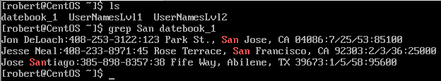

**grep San datebook_1**

Comments: Grep + **word** + filename. Grep will search for the given string the filename.

1. Print all lines where the person's first name starts with**J**

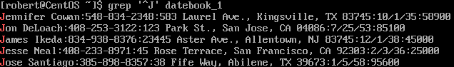 **grep ‘^J’ datebook_1**

Comments: **^** indicates to search for the word at the beginning of the file.

1. Print all lines ending in 700

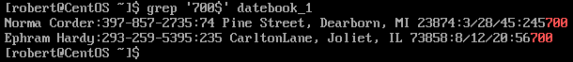**grep ‘700$’ datebook_1**

Comments: **$** indicates to search for the word or number at the end of the file.

1. Print all lines that don’t contain 834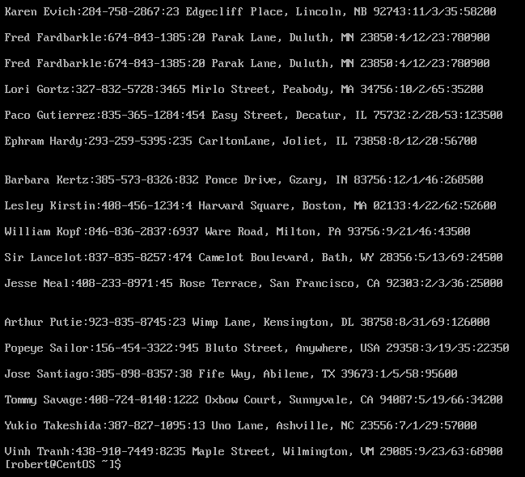 **grep -v “834” datebook_1**

Comments: **-v** means to avoid and print lines that do not contain the given word or number.

1. Print all lines where birthdays are in December 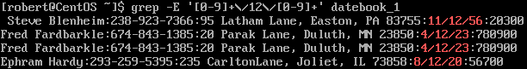

**grep -E ‘[0-9]+\/12\/[0-9]+’ datebook_1**

Comments: **grep -E**: It is to tell grep that we are going to use metacharacters.

What are metacharacters? They are characters that has special meaning to a computer program.

**‘ ‘** : We start writing the formula inside an apostrophe. Everything inside will be combined.

**[0-9]** : We are telling grep to search for numerical characters from 0 to 9.

**+** : means **followed by**

**\/** : The Date format is writing as 8/12/20. However, a single slash means another input in grep. To write a slash in grep we must type as \/.

1. Print all lines where the phone number is in the 408 area code

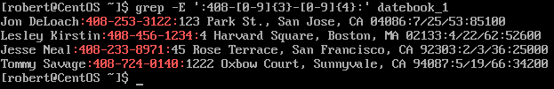**grep -E ‘:408-[0-9]{3}-[0-9]{4}:’**

Comments: As I explained above, we need the command Grep -E to tell grep that we are going to use metacharacters. Think this as a program language that grep use. We open the apostrophe and start typing 408 because we want to print all lines that start with the 408 code.

Dash - : We use the dash for field separators and because that is how the phone number format is typed 408-254-0564.

**[0-9]{3}** : We are telling grep to search for numerical characters as I explained above. The **{3}** represents the digit. Overall, we are telling grep to search for numerical character that contains 3 digits numbers**. [0-9]{4}** same theory, we are telling grep to search for numerical characters that has 4 digits.

1. Print all lines containing an uppercase letter, followed by four lowercase letters , a comma, a space, and one uppercase letter.

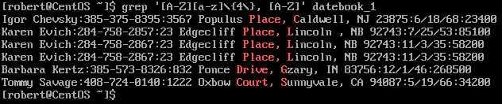**grep ‘[A-Z][a-z]\{4\}, [A-Z]’**

Comment: We want an upper-case letter at first, so we write ‘**[A-Z],** followed by four lowercase letters, so we write **[a-z]** **\ that has** **{4\}**. The four represent the number of characters. The back slash represents “that must have” and we must close the formula by adding another back slash at the end of the digit four. Then the rest is obvious, we write a comma, a “space”, and another upper-case alphabetical bracket **[A-Z]**.

**[A-Z]**:We are telling grep to search for Upper Case alphabetical characters from A to Z.

**[a-z]**: We are telling grep to search for lower case alphabetical characters from a to z.

**Back Slash \** : means **that has**

1. Print lines where the last name begins with K or k .

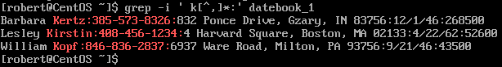**grep -i ‘ k[^, ]*:’**

Comments: I decided to put a space before the string “ k” because I saw that the last name in the file has a space before the first name. Then I decided to not include comma **[^,]**. I did it because there were addresses that start with K and ended up with commas. Finally, I decided to finish with a semi colon. Reason behind was because the last name followed up with couple of semi colons at the end of the column. I know there are more practice ways to do this command, but this one was the one that worked for me.

**grep -i** : Grep will look for the given string regardless of upper or lower case.

**[^ ]** : It means anything that does not contain.

**\*Asterisk** : means one or more prior the given character

1. Print lines preceded by a line number where the salary is a six-figure number.

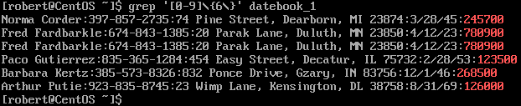**grep ‘[0-9]\{6\}’**

Comments: We want grep to search for numerical character **[0-9].** Back Slash **\** : In my opinion a back slash means “**that has**”. The **{6\}** means that the numerical character must have 6 digits. We must add a back slash at the end of the 6 to close the formula. At the end, we are asking grep to search for numerical characters that has a 6-digit numbers.

1. Print lines containing Lincoln or lincoln (remember that grep is insensitive to case).

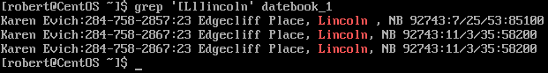**grep [‘Ll]incoln’**

Comment: We want to search for the word Lincoln and its lower-case version.

**[Ll]** : Anything inside the bracket will get add to the remaining words outside the bracket. We also have to make sure to add the apostrophe at the beginning of the word as well as at the end. Grep will search for the Upper-Case word Lincoln and the lower-case word lincoln. The changes will only occur inside the brackets. Grep will take the “L” and add it to the “incoln” phrase. Then Grep will take the next word, which is the “l” and add it again to the “incoln’ phrase.